The Power of Negative Thinking
When we talk about spaces in drawing, we are usually referring to ‘negative spaces’, which are the shapes that surround the ‘positive forms’. I touched briefly upon this in my 3 handy tips for learning to see like an artist.
In simple terms, if you are drawing a figure, the positive forms are the shapes that make up the form of the figure, and the negative spaces are the shapes created by everything outside of the figure (i.e. the background of the drawing and the gaps in the figure where the background shows through.)
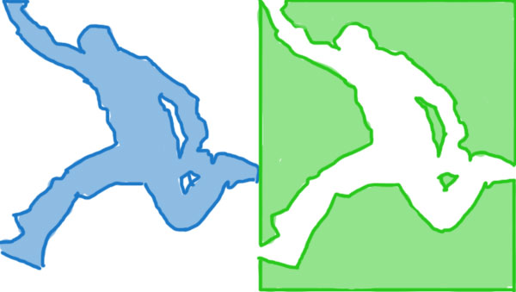
Positive form in blue (left) and negative spaces in green (right)
The reason we are taught to focus on negative spaces when drawing, is that these are usually abstract shapes, and it’s much easier to draw them accurately, because our brain has no language-based concept of how these shapes should look.
If someone drew a random shape on a piece of paper, and asked you to copy it, you’d probably do ok, because you would be forced to copy based purely on the appearance of the shape.
But if someone gave you a picture of a person and asked you to copy, say, the shape of the right leg, you would probably find it harder, because you’d naturally refer to your preconceived knowledge of what a leg should look like, which would lead to an inaccurate drawing.
So we focus on negative spaces to remove the left-brain tendency to draw what we think we see instead of what we actually see.
The magic part is that by accurately drawing all of the negative spaces, we are automatically drawing all of the positive forms too, without realising it (as the edges of every negative space form a boundary with a positive form).
So for example, you can draw a series of 11 abstract shapes, and before you know it, you’ve drawn a bench, without even trying to draw a bench!
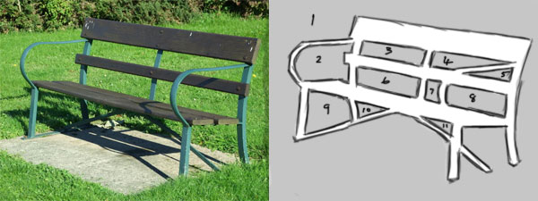
By drawing the 11 abstract shapes (in grey on the right), we have also drawn the main structure of the bench

How Do You Draw an Eye? Simple, You Don’t!
A common question I’m asked by beginner artists is ‘how do I draw eyes?’, ‘how do I draw faces?’, ‘how do I draw XYZ?’
The best answer I can give, other than ‘just draw what you see’ (not helpful), is don’t draw eyes, faces or whatever, but draw the negative spaces. In effect, draw everything you see except for the thing you’re trying to draw, and you will find it magically appears, looking more convincing than you believed possible!

