Room 162A Alycia.Roach@whcsd.org 216.336.6670
Welcome to Mrs. Roach’s Art II Class

Art II is filled with projects and activities that will refine your critical thinking habits, continue your collaborative participation, and develop your own artistic style. We will focus our further knowledge and application of art creation through the Elements and Principles of Art.
Art II is an extension of and outgrowth from Art I, designed for students who have an interest in refining their individual art skills and techniques
In this class you will…
- Generate and conceptualize artistic ideas and work.
- Push yourself to go beyond requirements and basic techniques.
- Apply techniques learned in art one to develop your own style.
- Organize and develop artistic ideas and work.
- Refine and complete high-level art work. Analyze, interpret, and present art work.
- Refine and mat art work for art shows.
- Convey meaning through the presentation of artistic work.
- Perceive and analyze artistic work.
- Interpret intent and meaning in artistic work.
- Apply criteria to evaluate artistic work.
- Use personal experiences to develop art.
- Relate artistic ideas and works with societal, cultural and historical context to deepen understanding.
- Behave according to the school and classroom rules.
Prerequisite: C or higher in Art I or written permission from instructor
Grading:
For each project/unit you will be earn a letter grade based on rubrics. Rubrics will be used for student self-assessment as well as instructor assessment and given to student before the project begins. Grading scale will follow WHCSD grading policy.
The rubric sections may be, but are not limited to:
Preliminary planning, sketches, quality, craftsmanship, work ethic, labeling, etc.
Class Assignments (what you will be graded on):
Studio project, class participation/preparatory exercises, collaborative projects, assessments, and homework.
THERE IS NO EXTRA CREDIT, just regular credit. Attendance is imperative.
Open Studio is a time posted in the classroom that can be used for extra production time needed BEFORE the due date. This may change weekly, so be sure to check the posted time and day.

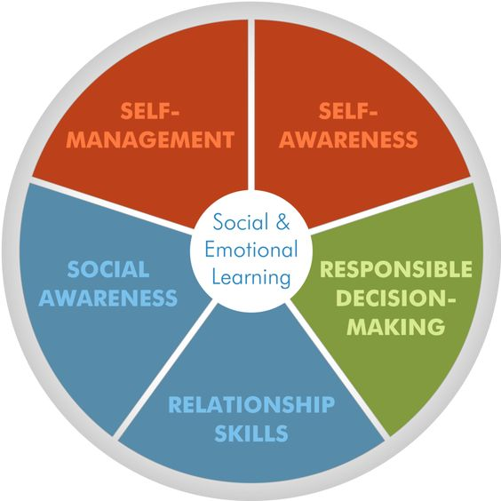
Supplies you will need daily:
- #2 pencil, not mechanical
- Large eraser
-You will need more supplies later in the year, but I will provide ample time to get them.

Actions are choices; choose wisely. For every actions there is an opposite or equal reaction. This means is you act positively there will be positive consequences and vice versa.
Respect others, always. This is where I will say to be nice or be quiet. All guests, substitute teachers, and students will be treated with kindness and respect. If you want respect, be respectful.
Tools will be used, cleaned, and put away properly. The tools of art will differ as well as safety requirements. Be careful and mindful about the supplies that are provided to you by the WHCSD and Mrs. Roach.
Grading
Projects (exercises, preparatory activities, in class work) 70%
Summative Assessment (tests, quizzes, etc.) 20%
Final Exam 10% (at the end of each semester)
ART II Skills and Techniques learned and applied through project-based learning.
Self-Portrait Drawing, Correct Proportions, Shading, Blending, Color theory, Painting, Grid Transfer Method, Surreal Perspective, Advanced Negative Space drawing, Mixed Media Collage, 3-D Sculpture (recycled materials)
Personal Style Development, Creative Planning, Problem Solving, Pencil Drawing Pen / Marker Drawing Exploring Shapes, Painting Abstract Art, Colored Pencils, Techniques Color Blending, Observational Drawing, Watercolor and watercolor effects, Adding Value and different Value Techniques, Line Drawings
Multi-color Stipple, Implied Texture Drawing Techniques, Clay Construction, Color Chalk pastels, Acrylic Paint

