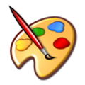
Room 162A Alycia.Roach@whcsd.org 216.336.6670
Welcome to Mrs. Roach’s Art I Class.

Art I is a foundations course filled with projects and activities that will boost your critical thinking habits, improve your collaborative participation, grow your creativity and develop your communication skills through writing and talking about art. This will prepare you for further exploration to high level art classes. We will focus our exploration of the art world through the Elements and Principles of Art.
Grading:
For each project/unit you will be earn a letter grade based on rubrics. Rubrics will be used for student self-assessment as well as instructor assessment and given to student before the project begins. Grading scale will follow WHCSD grading policy.
The rubric sections may be, but are not limited to: Preliminary planning, sketches, quality, craftsmanship, work ethic, proper labeling etc.
Class Assignments (what you will be graded on):
Studio project, class participation/preparatory exercises, collaborative projects, assessments, and homework.
THERE IS NO EXTRA CREDIT, just regular credit. Attendance is imperative. *You have until the end of the quarter to submit work (see open studio information).
Open studio is a time posted in the classroom that can be used for extra production time needed BEFORE the due date. This may change weekly, so be sure to check the posted time and day.
*This time is to be used for extra time needed for projects, resubmitting an improved or finished artwork, and/or submitting one that was not turned in on time only for that quarter. THIS IS THE ONLY TIME YOU CAN TURN IN LATE WORK OR TO BE RE-GRADED AFTER IMPROVEMENT.

In this class you will…
- Generate and conceptualize artistic ideas and work.
- Explore a variety of media.
- Organize and develop artistic ideas and work.
- Refine and complete art work. Analyze, interpret, and present art work.
- Develop and refine artistic work for art shows.
- Convey meaning through the presentation of artistic work.
- Perceive and analyze artistic work.
- Interpret intent and meaning in artistic work.
- Apply criteria to evaluate artistic work.
- Synthesize and relate knowledge and personal experiences to make art.
- Relate artistic ideas and works with societal, cultural and historical context to deepen understanding.
- Behave according to the school and classroom rules.

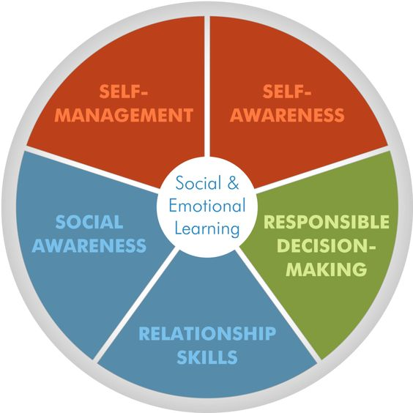
Supplies you will need daily:
- #2 pencil, not mechanical
- Large eraser
-You will need more supplies later in the year, but I will provide ample time to get them.

The Expectations of ART
Actions are choices; choose wisely. For every actions there is an opposite or equal reaction. This means is you act positively there will be positive consequences and vice versa.
Respect others, always. This is where I will say to be nice or be quiet. All guests, substitute teachers, and students will be treated with kindness and respect. If you want respect, be respectful.
Tools will be used, cleaned, and put away properly. The tools of art will differ as well as safety requirements. Be careful and mindful about the supplies that are provided to you by the WHCSD and Mrs. Roach.
Grading
Projects (exercises, preparatory activities, in class work) 70%
Summative Assessment (tests, quizzes, etc.) 20%
Final Exam 10% (at the end of each semester)
Art I Skills and Techniques learned through project-based learning.
Drawing, Eye-Hand Coordination, Proportions, Shading, Blending, Color theory, Painting, Grid Transfer Method, Drawing in Proper Perspective, Negative Space drawing, Mixed Media
Creative Planning Problem Solving Pencil Drawing Pen / Marker Drawing Exploring Shapes, Abstract Art, Colored Pencils, Techniques Color Blending, Observational Drawing, Watercolor and watercolor effects, Adding Value and different Value Techniques, Line Drawings
One Color Stipple, Implied Textures Techniques, Clay Construction

