Still Life in Pencil
Power Point (text only)

Step 1: Sketches
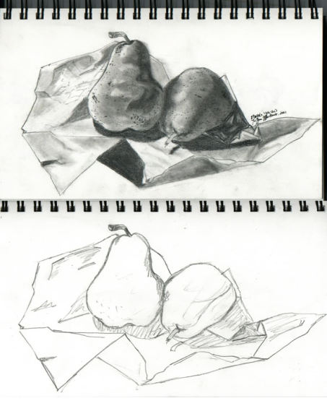
- You will complete 2 sketches from two different places/views
- You will add in some basic value and little detail
- You will choose your final view from these sketches.
Step 2: Contour Line
- After you chose your spot that you will stay in for the duration of the project, you will complete a contour line drawing on your final paper (this will be an extension of your chosen sketch)
- Keep it light so if you need to erase it will not be too hard to fix.
- Objects are to be drawn in as you see them, think overlapping placement of objects etc.
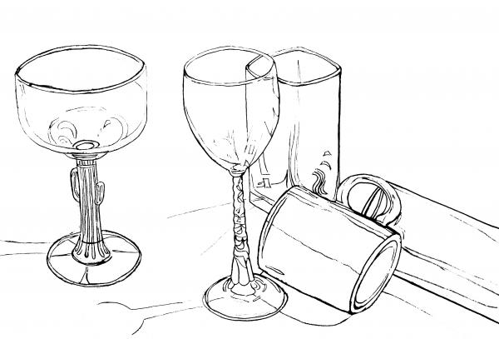
Step 3: add light texture
- Use calligraphic (light, moving lines) to show textures and areas between light and dark.
- This will determine the spaces that you will need to go back and add value to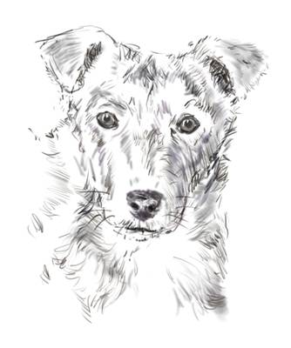
Step 4: Add value (slowly)
- Add value only where you see it!
- Only draw what you see not what you think should be there!!!!!
- Take your time adding value
- Start light and then get heavier in adding value (it is hard to erase value)
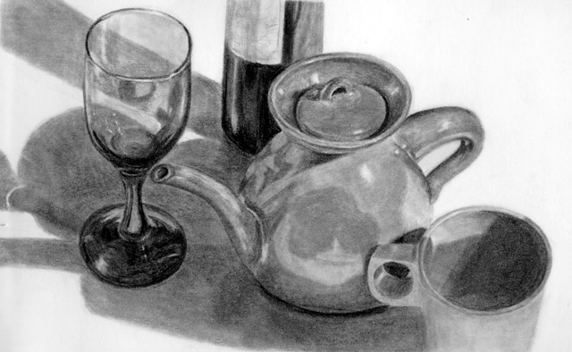

Do a self-check
- Ask your neighbor to sit in your seat for a minute and get their opinion on how you are doing
- Work each day and be sure to continue working
- Do not tell me you are done, it’s rare that I will agree with you!
- A drawing can always be changed and improved.

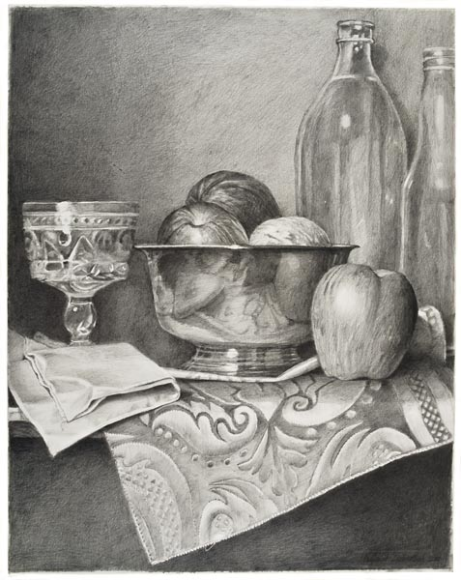

Rubric
 | 3 | 2.5 | 2 | 1.5
Students have completed two 10 minute sketches before starting the final drawing
Student has added value to make objects, shapes and forms appear to be three-dimensional. Students have use techniques learned in class to complete the project. Students have at least 5 objects and 9 different values present.
Student has put the name date and period on the back and their signature in the lower right hand corner on the front in pencil.
Student has been prepared daily and worked the entire time given. Student has used time efficiently.

