Positive and Negative Space
Positive Space- is the object(s) or people in the composition
Negative Space is the empty area around the positive space (objects)

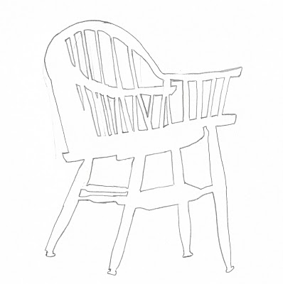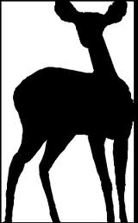

This is similar to what you will do!

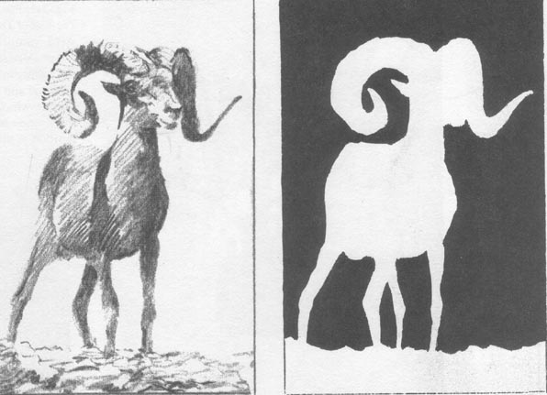

Positive Space Drawing Negative space drawing

It is NOT a chair Drawing (it is just lines and shapes)

In the room we have two chairs that are on white back drops.

- You will turn to face your entire body to the object(s) you are drawing (if you need to move your chair do it quickly and quietly)
- You are not drawing the chair you are drawing the negative spaces between the positive object.
- You are drawing the white shapes that are created by the lines of the “chair”
- It is not a chair! It is a composition of shapes and lines.
Notes:

Use the lost and found to establish where you are going to make the spaces.
Use broken line to lightly add the rest of the shapes of the negative space
If you mess up, make your new line first then erase the one you do not want!
Talk to yourself to establish right bright use!

