Great compositions don’t just happen by accident. They take planning, patience, and a knowledge of all the visual elements at your disposal. The great thing is, no matter how much or how little talent you have, you’ll always be able to improve your art by sketching out a good composition before you begin.
With that in mind, here are the 9 steps for better compositions:

1. Pick a good subject
This one might be a no-brainer, but you can’t have a great composition without something good to compose! Obviously your composition depends a lot on what you’re actually painting or drawing, so pick something interesting (visually at least), and always make sure that there’s a good light source from one direction to give the object a strong highlight and shadow. I like painting stuff with a lot of color, texture, sharp angles, etc, since those will increase a viewer’s interest.

2. Choose the size you want
How big do you want to portray your subject? The scale of art can change its entire feel, so it’s important to have a purpose for making an object larger or smaller than life.
For instance, a large, 6ft diameter painting that enlarges an object like a penny will have much more importance and meaning than a normal-size painting of a penny. By enlarging objects, you increase importance; reducing size usually diminishes importance. If you’re not sure what size to make it, just keep it as close to life-size as possible.

3. Create your own crop
Often the most powerful lines in a work of art are the four that most artists don’t even think to control. The edges of your canvas or paper are responsible for containing and shaping your final work of art. Why settle for drawing inside somebody else‘s lines? Make your own! If you’re planning on drawing a skyscraper, cut your paper to the height and width necessary for your subject. Painting a landscape? Why not make your canvas wider, for a panoramic view? This can be used to enhance practically every work of art, so make sure to think about it before choosing to use a standard canvas or paper.

4. Think about placement
The way you place shapes on a 2-dimensional surface lend levels of importance, meaning, and balance to a piece. Centering your subject vertically, horizontally, or both will always give a greater sense of stability to your work, but might end up feeling a little boring or typical as well.
Letting part of your subject get cropped off by the sides, top, or bottom will usually add more visual interest, as will making a single object fill the entire space. Do watch out for objects that barely touch edges, or for objects that just barely brush the borders of your artwork. This type of placement is awkward and should be avoided.

5. Control your lines
Any subject you choose will have at least an outline as well as other lines to give it depth, texture and detail. Our eyes naturally follow lines, so use that to your advantage in capturing the viewer’s gaze. Let your lines flow to the center of your work, or to the spots that you want the viewer to look at. Angled or curved lines generally add more visual interest and movement, but too much can be chaotic. Horizontals and verticals lend strength, solidity, and impressiveness but can be boring.
Avoid letting lines divide your art exactly in half; like with a horizon line running through the middle, or vertically with a tree. This pulls the viewer out of the space you’ve created and will distract from the image.

6. Balance positive and negative space
Positive space is any object or shape that stands out from the background and registers to the eye as “something.” Negative space is the background, or space around objects. Usually it’s suggested that you keep approximately equal amounts of positive and negative space to make a work feel more balanced. If you don’t have enough negative space, your art may feel busy and crowded, but too much negative space can cause the work to feel empty and subdued.
On the other hand, a busy, crowded painting may be your intent, and using a lot of negative space often works well at focusing attention on the positive space that is there. You get to choose how you want your art to feel, so pick a balance that’s right for your subject matter and style.

7. Add contrast
Visual art should have a full range of values from dark to light. Without bright highlights and dark shadows, an image will often feel gray or washed out, and will be less interesting. Darker areas in a predominantly light section will stand out and draw the eye, and the same is true for the reverse. Use this to focus attention but watch out for unintentionally doing so. Make sure you’re not adding emphasis to a corner or edge of a painting if your focus is meant to be in the center.

8. Simplify distracting elements
Too many shapes, lines, or colors can distract or confuse viewers. If you want the viewer to notice or return consistently to one part of the painting, simplify the rest of it. Decide what the focus should be and if YOUR eye gets distracted, change it! Another way to simplifying your art is to get closer to a single object. Leaving out the peripherals and zooming in until the whole frame is filled with only one thing always brings attention where you want it. Of course, doing so will change your positive/negative balance drastically.

9. Choose your colors deliberately
Bold color will catch attention so use them purposefully where you want people to look. Any color that’s all alone surrounded by another color will also stand out. Just like with contrast, this can happen unintentionally, so check for it in your composition.
Also be aware that warm colors (yellow, orange, and red) will make objects appear closer to the viewer, so use them to create depth and space. Cold colors (blue, purple, and some green) will cause objects to recede into the distance. When an object in the “back” of your painting is too warm, it’ll distract from your overall composition and pull attention where you don’t want it.
Finally, I’m a die-hard fan of sketching at the beginning of each creative process so I’d always recommend drawing out different compositions until you feel as though you’ve exhausted every option. If sketching’s not your thing, you could take a bunch of photos and then alter them digitally to find the best composition for your subject.
Whatever you do, don’t jump into something you have high hopes for without working through each of the steps above. I guarantee that if you follow the guidelines above, you’ll be amazed at the difference between your final composition and what your original idea actually was.

The secret of good composition
by Will Kemp
in drawing
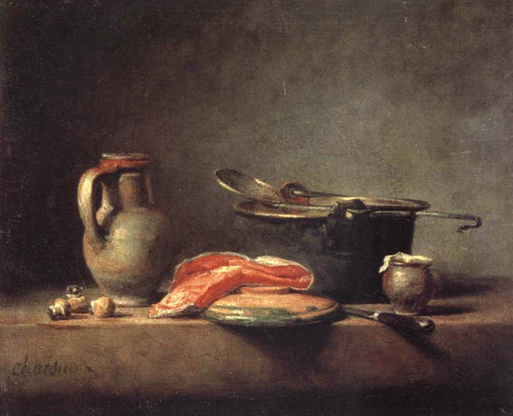
‘And after drawing comes composition. A well-composed painting is half done’
Pierre Bonnard
Imagine a lovely drawing of a house with a path meandering up to it, trees either side in careful balance, a classic landscape scene that just ‘works’.
Where is this masterpiece? The Tate? The National?
No, stuck to your fridge door, created by a 4 year old.
As a young child visual harmony and composition comes naturally.
Children seem to start out with a near perfect sense of composition, if you have small children or are lucky enough to have any of your old drawings you created as a child I’m sure you’ll find the same to be true.
Younger children see the edges of the paper as a whole frame to fill, and they often fill them with a great sense of balance.
When you start to grow up, you know – really old like 9 or 10, that’s where the drawing problems start. The focus shifts and is aimed away from composition to the pursuit of something far more important, where the accolades are huge and respect even greater, the quest for the ultimate prize …… realism…

A reframing of priorities
The importance that was once placed on the edges of the page, the ‘wholeness’ of the piece are disregarded in favor of singular objects, and the representation of these objects as accurately and as detailed as you can possibly make them.
The prize is no longer for composition, a 10 year old doesn’t care, the focus is on accuracy and realism especially ‘hard things to draw’ like hands or faces. But the ultimate goal, the real award winner is this….If you can draw a crumbled can of Coke realistically you are king of the art room.

The simplest way to start
Once you have diverted from the path of composition in childhood it is hard to get it back, and you will have a natural tendency to place objects in the centre of a piece, this is due to the strong symbol systems formed in childhood.
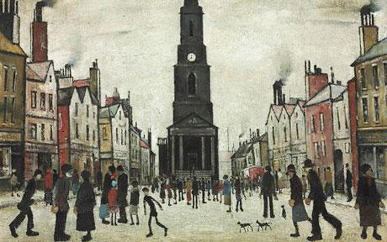
Lowry embraced this simplistic quality resulting in his paintings looking childlike.
It is not only through the handling of the paint, but the composition of his painting where everything is biased towards the centre.
If you want to make the jump towards a more sophisticated composition there are a few things to consider.

Choosing a format, square or rectangle
A format is just another word for shape, and this comes down to personal preference. From squares, rectangle, panoramic. The easiest shape to create a balanced composition
is a rectangle, just like an A4 piece of paper.
The rectangular format: this is an absolute classic and extremely flexible format. When a rectangle is displayed with its shorter side across the top it is known as ‘portrait format’ and with its longer side across the top ‘landscape format’.
The square format: This can work extremely well or very badly. You very rarely see a square old master painting. This is because it is harder to balance a painting that has lots of elements within, for example, a collection of figures in a landscape within a square format. It can look awkward very easily. However, using a square format for a more contemporary subject, an abstract or a minimalist seascape, can be very effective.

3 is the magic number
- Composition is about variety just “don’t make any two things the same”
- The “Rule of Thirds” can be key to creating balance in landscape painting
- Make sure the shapes, spaces and gaps between objects are all different.
com·po·si·tion/ˌkämpəˈziSHən/Noun
1. The nature of something’s ingredients or constituents; the way in which a whole or mixture is made up.
2. The action of putting things together; formation or construction.
Composition can be confusing and hard to pin down, you don’t really notice good composition in a painting it is just there, which is why it is one of my 7 principles of painting . The dictionary definition above doesn’t necessarily help us. ‘the action of putting thing together‘ well, this is true but the actions of putting things together so they ‘work’ is harder to explain.
If colour mixing is about relationships, the warm to the cool, the bright to the muted then composition is about variety- busy to calm, large and small.
Don’t make any two things the same. If you’ve got a row of fence posts going into the distance – check the gaps, they should all be different.
If you have a simple still life with a jug and some fruit – check the heights, they should all be different, check the width, they should all be different.
This seems very straightforward, and it is. It is just a simple way of analyzing your initial set up. Is this method true for all paintings? No, but the more you look, the more you will notice this to be true.

The rule of thirds
What is the Rule of Thirds?
The rule of thirds is very commonplace in photography. It instantly helps to add tension, balance and interest to your photograph but applies equally to composition in painting. When creating a landscape composition this is what you do:
1. Divide your page horizontally into 3.
2. Decide whether to have your horizon on the top third or the bottom third (the bottom third is always easier to balance, it helps to make the sky look vast and imposing).
3. Split the vertical into thirds.
4. Align areas of focus at the intersection between the lines.
5. Marvel at your genius
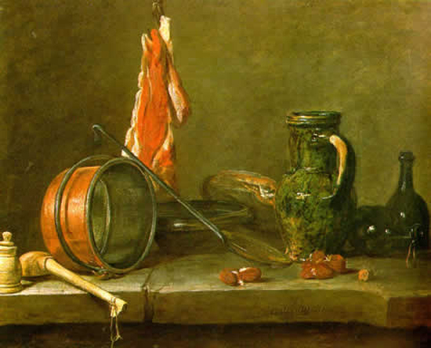
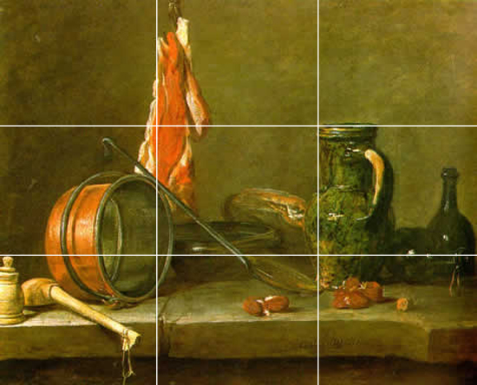You can see in the Chardin painting above how there are numerous examples of aligning objects within the rule of thirds, the top of the jug aligns with top horizontal line and sits butted up to the vertical line, even the top of the funny little pot on the far left side sits on the bottom horizontal line, to name a few.
Pro tip: If you have a mac, iphoto does all the work for you. It can change the size and the rule of third lines are already on the screen for you. Align, resize, repeat.
How your digital camera can help your composition
Your digital camera probably has a view finder function built in, often called grid. It again overlays the rule of thirds over your image, just align important compositional elements along these lines or their intersections and voila… instant painting.
A word of warning
Rule of thirds can work very well within a rectangle, however, for landscapes squares can be a harder to create a balanced painting even when sticking to the ‘rules’.

A Brief History
The rule of thirds was first written down by John Thomas Smith in 1797. In his book Remarks on Rural Scenery:
“Rule of thirds”, (if I may be allowed so to call it)…, in a design of landscape, to determine the sky at about two-thirds ; or else at about one-third, so that the material objects might occupy the other two : Again, two thirds of one element, (as of water) to one third of another element (as of land); and then both together to make but one third of the picture, of which the two other thirds should go for the sky and aerial perspectives.”
If you put the principle of ‘no two spaces the same’ with the ‘rule of thirds’ you can create pleasing compositions very easily. If we analyze the quote below by Sir Joshua Reynolds we can see how both these points are touched upon.
“Two distinct, equal lights, should never appear in the same picture : One should be principal, and the rest sub-ordinate, both in dimension and degree : Unequal parts and gradations lead the attention easily from part to part, while parts of equal appearance hold it awkwardly suspended”
This last comment is the key, nobody wants a painting ‘awkwardly suspended’. He also comments on the importance of contrast when creating a harmony to your work:
“And to give the utmost force and solidity to your work, some part of the picture should be as light, and some as dark as possible : These two extremes are then to be harmonized and reconciled to each other.”

The golden mean
Classical paintings had a very scientific and structured approach, with lots of confusing things like root rectangles and golden means. They are often more mathematical and planned out than you would ever imagine….whooahh there, we are moving into complicated classical territory which deserves a proper explanation, which I will address in a future post.
The key point to remember with composition is about variety - just “don’t make any two things the same” and start with a rectangle canvas.

