Draw a Box Using One-Point Perspective
Let's draw a box using one-point perspective. First, draw a horizon line about one-third down your page. Mark a spot roughly in the middle of the line. That's your vanishing point.

Now, draw a rectangle about two-thirds down the page, roughly in the middle. Lightly draw lines from the top two corners to the vanishing point.

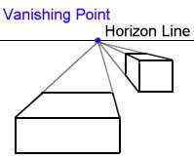
Draw a horizontal line between these two orthogonals ('vanishing lines'). This is the back of the box. Darken the lines between this horizontal and the box, and erase the rest of the vanishing lines up to the horizon. There! A 3-D box.

If you draw a box to the side of the vanishing point, you will need to also draw a vanishing line from the bottom corner, as show in the example. When you draw the horizontal to make the back of the box, just drop a vertical line from where it meets the top orthogonal down to the bottom one, to give you the rear edge of the box.

Experiment drawing boxes in different places in relation to the vanishing point and horizon.

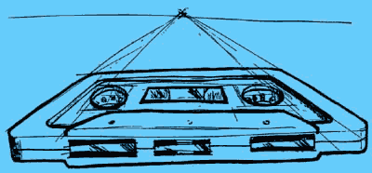
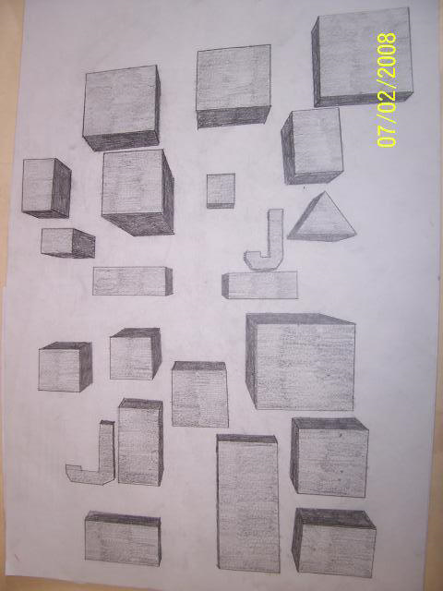 This is an example of Assignment #1

